**What Teachers Need to Know about the Human Brain**

**What is wrong with the student?**

The question should be, “What is stopping them from making the connections?”

Learning occurs when tied to:

Senses Connections Prior knowledge Emotion Play Positive feedback

Encoding is a biological event beginning with perception through the senses. The process of laying down a memory begins with attention (regulated by the thalamus and the frontal lobe), in which a memorable event causes neurons to fire more frequently, making the experience more intense and increasing the likelihood that the event is encoded as a memory. Emotion tends to increase attention, and the emotional element of an event is processed on an unconscious pathway in the brain leading to the amygdala. Only then are the actual sensations derived from an event processed.

**What do I project?**

Now the question is, “What I am doing to help/inhibit the student and their connections.”

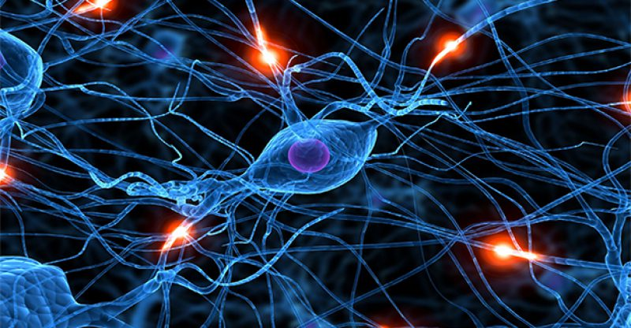

**How Can I help the student(s)?**

**Language Learners:**

Functioning at a high cognitive/high stress level

Emotions that inhibit might be different from domestic freshman

Starting place for connections is different